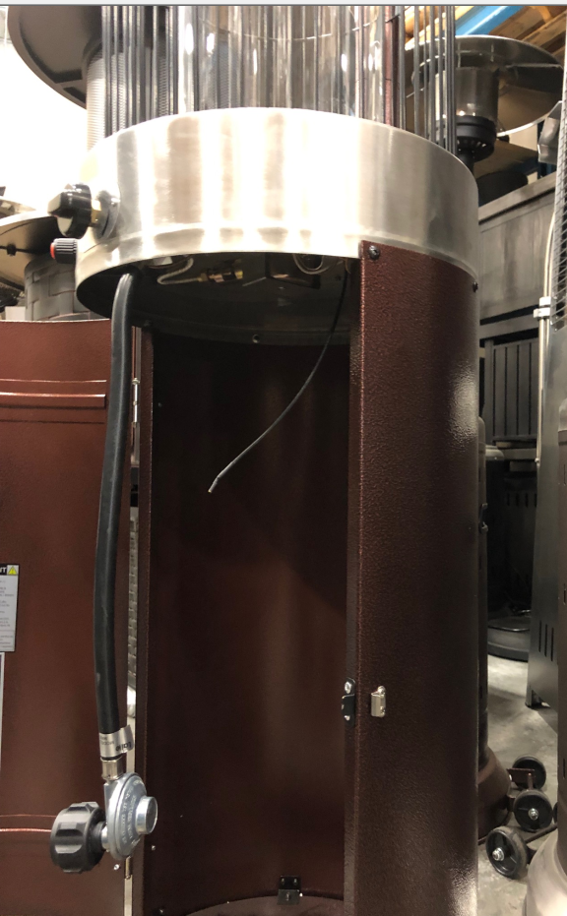
It is possible the igniter wire has come loose and needs to be reconnected. You will see the wire dangling when you open the propane tank door.
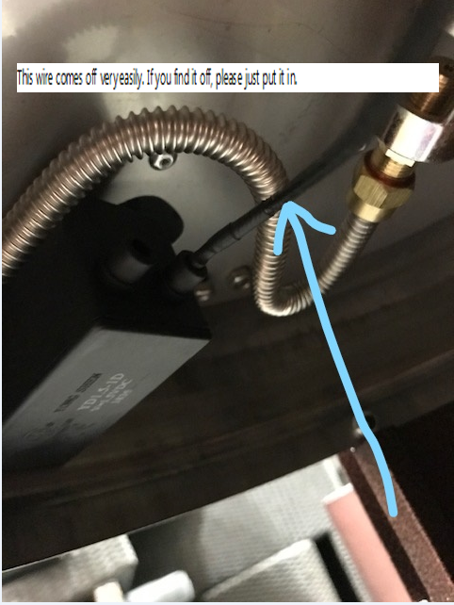
Reattach the wire to the back of the igniter box.

