JR Service Manual (model: JR 72”)

Introduction (see owner’s manual)
Operation (see owner’s manual)
Maintenance (see owner’s manual)
Exploded Parts Diagram and Replacement Parts List (see owner’s manual)
Wiring diagram (see owner’s manual)
Troubleshooting (see owner’s manual)
Preparation for service
! Note: All components are replaceable from the front of the fireplace while the unit is mount or recess inside the wall.
! Warning: Disconnect power before attempting any maintenance to reduce the risk of electric shock to persons.
! Caution: If unit was operating prior to servicing, please allow at least 15 minutes for lights and heating elements to cool off to avoid burning of skin.
Tools required: Philips head screwdriver or electric drill.
- Turn off the circuit breaker at electrical panel.
- Remove the front glass by unscrewing two screws on each side of the fireplace.
- Carefully lift and place the front glass aside in a safe location.
- Remove the acrylic ember bed tray.
- Remove the reflective mirror by unscrewing the metal strip bar on the upper side of the mirror. The metal strip is to secure the reflective mirror inside the fireplace. Carefully lift and place the mirror in a safe location.
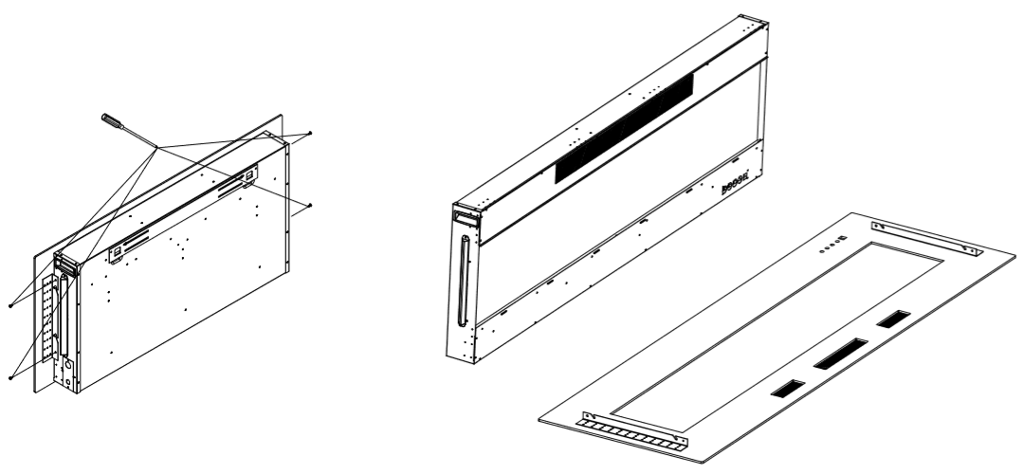
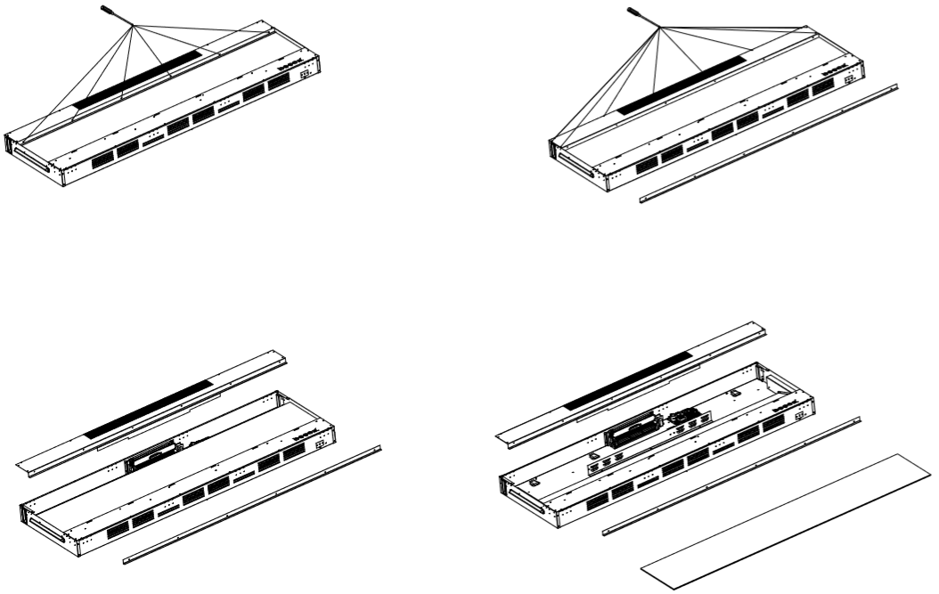

Main control board replacement
Caution and warning: Follow “Preparation for Service #1 - 8” instructions before proceeding replacement.
- Remove the top panel as seen from the diagram.
- Locate and remove the control board by removing the screw on each corner.
- Transfer the wire connections from the old board to the new board. Ensure that all wires are replaced and connected in the same position.
- Install the new board back to the panel.
- Reassemble the parts in reverse order.
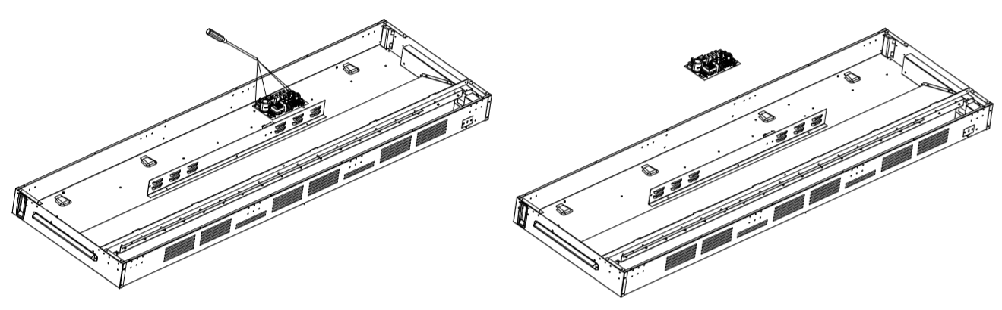

Heater/Blower replacement
Caution and warning: Follow “Preparation for Service #1 - 8” instructions before proceeding replacement.
- Remove the top panel as seen from the diagram.
- Locate and remove the heater by removing the screw on each corner.
- Transfer the wire connections from the old heating element to the new heating element. Ensure that all wires are replaced and connected in the same position.
- Install the new heating element back to the panel.
- Reassemble the parts in reverse order.
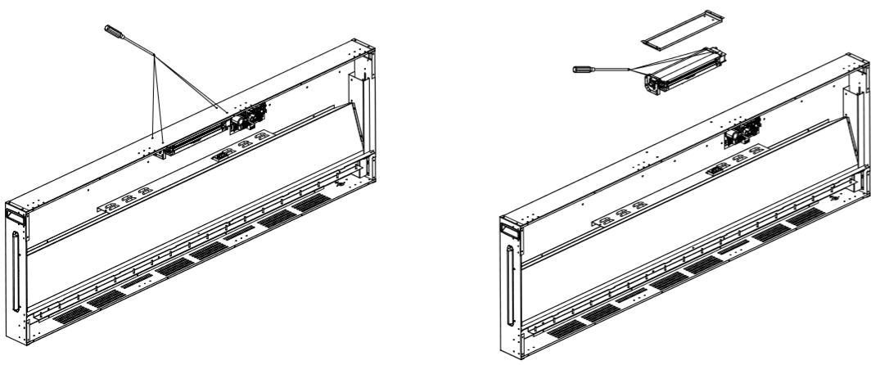
Bluetooth Speaker replacement
Caution and warning: Follow “Preparation for Service #1 – 5, 8” instructions before proceeding replacement.
- Remove the top panel as seen from the diagram.
- Remove Bluetooth speaker on the left side of the top panel by removing the two screws on the holder.

Ember bed LED replacement
Caution and warning: Follow “Preparation for Service #1 - 5” instructions before proceeding replacement.
- Remove all the crystals and media from the ember bed with a bucket or a box to keep the pieces together.
- Remove acrylic ember bed tray.
- Uninstall the ember bed LED bar.
- Unplug the wire from LED bar.
- Install the new ember bed LED bar.
- Plug in the wire back to LED bar.
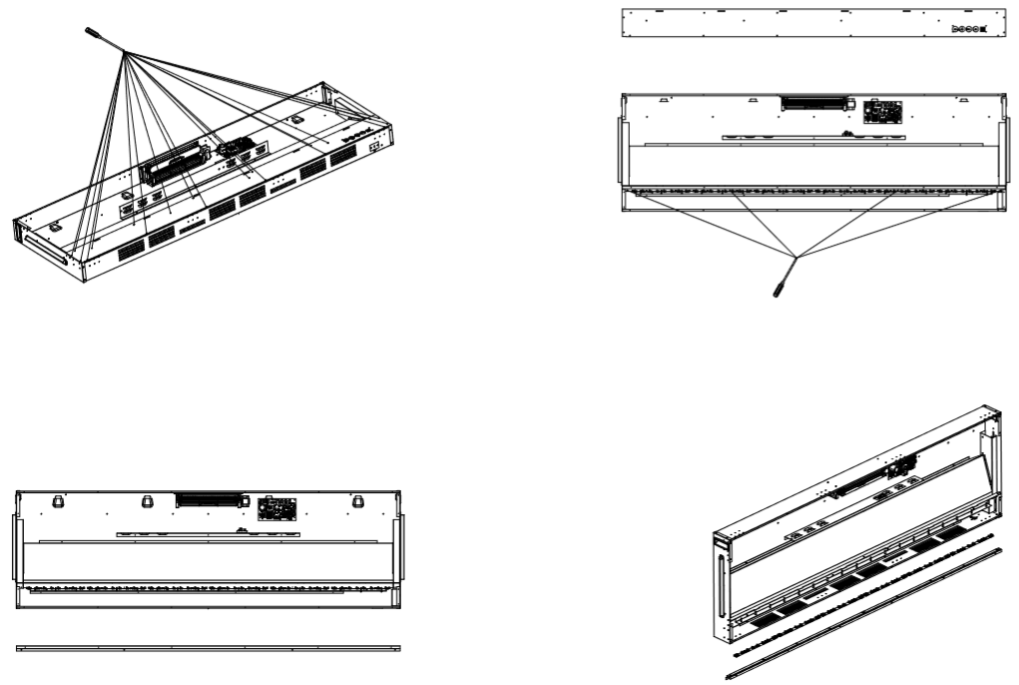

Flame Board replacement
Caution and warning: Follow “Preparation for Service #1 - 5” instructions before proceeding replacement.
- Remove vertical mounting brackets by removing four screws on both sides.
- Remove flame board by removing four screws on both sides.
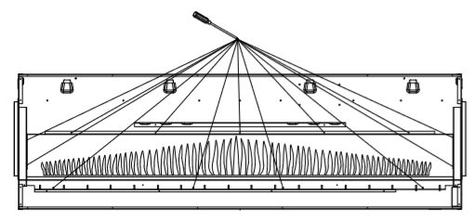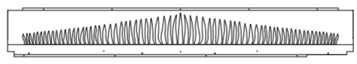

Rotary Drum Motor replacement
Caution and warning: Follow “Preparation for Service #1 - 8” instructions before proceeding replacement.
- Remove flame board as the flame board replacement procedure.
- Remove rotary drum by unscrewing the mounting brackets on both sides.
- Remove rotary drum motor by removing two screws on the motor mounting bracket.
- Detach rotary drum motor from the rotary drum by loosening the screw on the plastic tube between the motor shaft and the drum.
- Unplug the motor wiring and replace the new motor. Connect the wire back to the new motor.
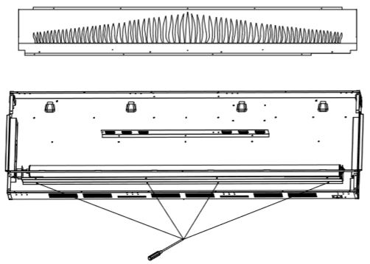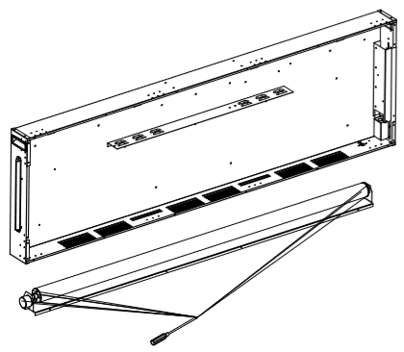

Rotary Drum replacement
Caution and warning: Follow “Preparation for Service #1 - 8” instructions before proceeding replacement.
- Remove flame board as the flame board replacement procedure.
- Remove rotary drum by unscrewing the mounting brackets on both sides.
- Remove rotary drum motor by removing two screws on the motor mounting bracket.
- Detach rotary drum motor from the rotary drum by loosening the screw on the plastic tube between the motor shaft and the drum.
- Remove the white cap on the motor sides and slide the plastic drum out of the drum mechanism.
- Replace the new drum and reassemble the parts in reverse order.
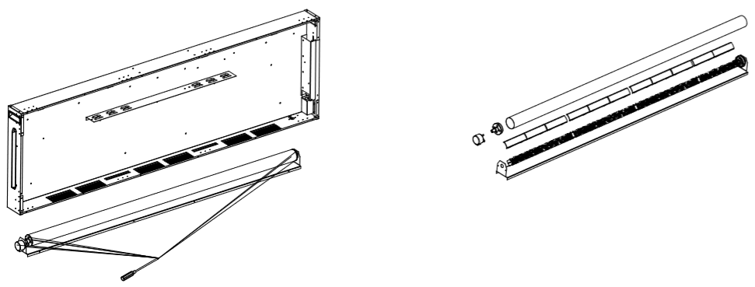

Rotary Drum LED light bar replacement
Caution and warning: Follow “Preparation for Service #1 - 8” instructions before proceeding replacement.
- Follow the procedure of the rotary drum replacement.
- Unplug the wire connection of the LED light bar, and replaced by the new LED light bar. Connect the wire back to the new LED light bar.
- Reassemble the parts in reverse order.

Hard Wiring connection
If it is necessary to hard wire this appliance, a qualified electrician must remove the cord connection, and wire the appliance directly to the house hold wiring. This appliance must be electrically connected and grounded in accordance with local codes, if hard wired. In the absence of local codes, use the current CSA C221.1 CANADIAN ELECTRICAL CODE in Canada or the current ANSI/NFPA 70 NATIONAL ELECTRICAL CODE in the United States.
Note: Leave enough wire so that the appliance can be removed from the enclosure without disconnecting the power supply.
- Remove the cover plate on the upper left side of the fireplace by removing two screws (when facing the fireplace direction).
- Remove the wire connectors from the power cord. The power cord may be discarded.
- Take the new cover plate, supplied in the manual bag. Punch out the 7/8” (22mm) hole and install a box connector through, into the junction box. Snap the box connector clamp onto the supply wires.
- Using the wire connectors, connect the ground green wire (G) and white wires (N) together, then hot black wires (L) and then refer to diagram.
- Reinstall the cover plate using the two screws, as shown in below figures.
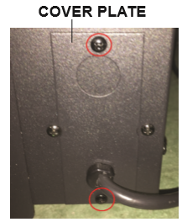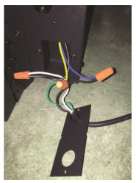
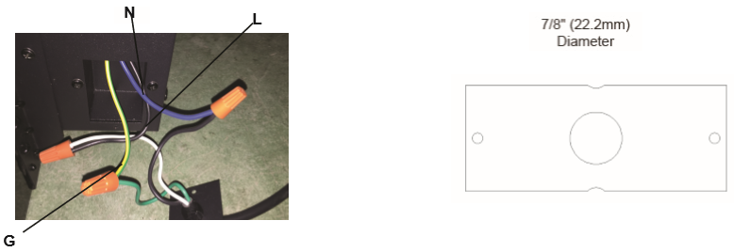

Wall Thermostat connection
Caution and warning: Follow “Preparation for Service #1 - 2” instructions before proceeding replacement.
- Remove cover plate located on the upper left side of the fireplace as shown in below pictures.
- Pull the wire out and cut the inside thermostat. Connect the wires to the wall thermostat as shown in diagram. Follow instructions provided with wall switch kit.
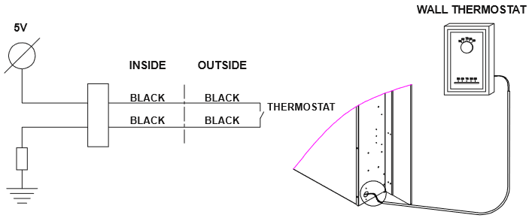
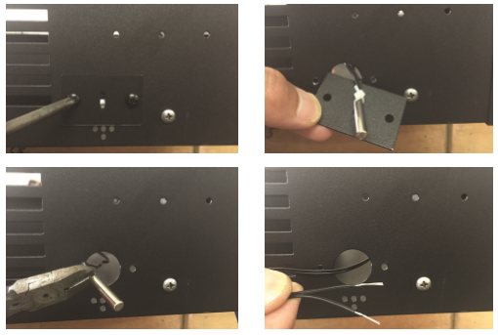

Remote Receiver replacement
Caution and warning: Follow “Preparation for Service #1 - 8” instructions before proceeding replacement.
- Remove the remote receiver board located on the upper side of the flame board as shown in below diagrams.
- Unplug the wire connection and replace a new board. Connect the wire back to the new board.
